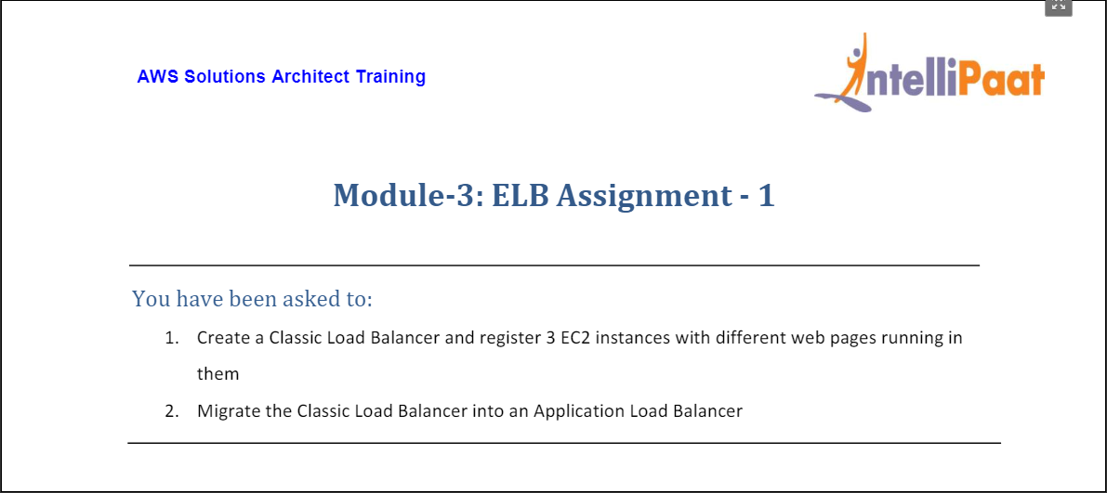

* Setup first EC2 instance named Webserver1 (IP: 54.82.82.191)

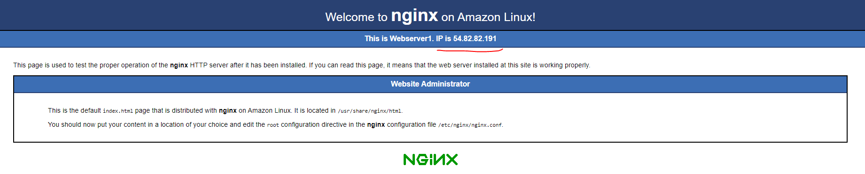

* Setup second EC2 instance named Webserver2 (IP: 3.95.201.88)



* Setup third EC2 instance named Webserver3 (IP: 3.88.224.206)

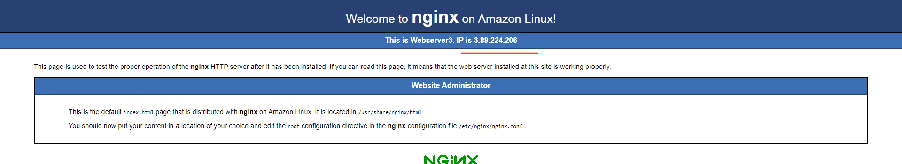

* A snapshot of all three EC2 instances running:

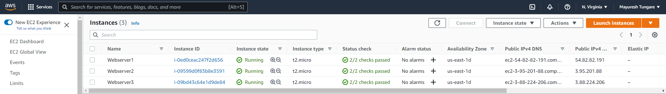

* Go to create a classic Load Balancer

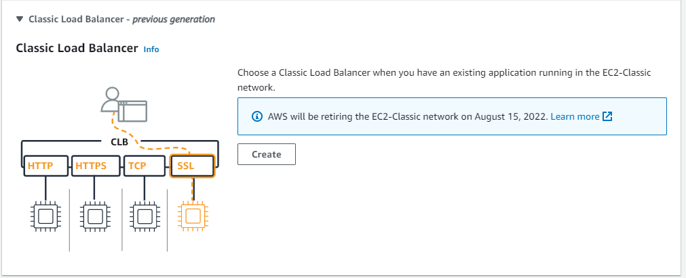

* Configure Load Balancer Healthy checks

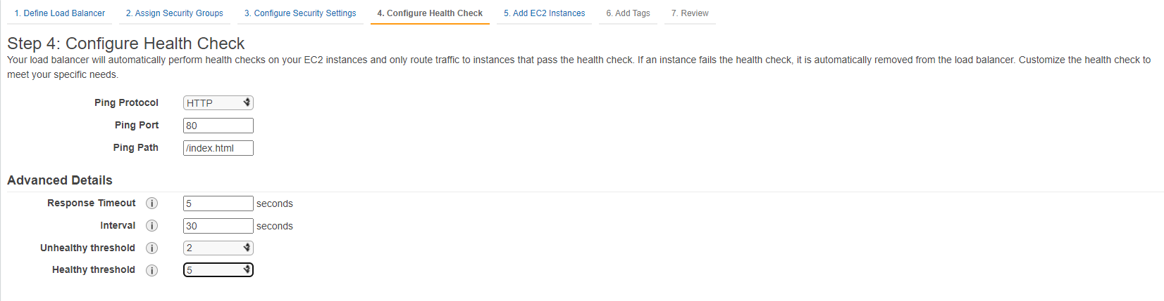

* Add the above three EC2 instances (Webservers 1, 2 and 3)

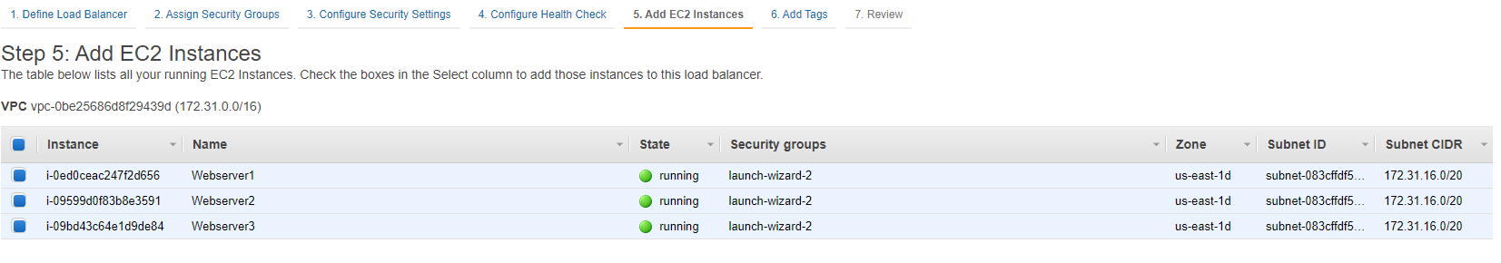

* Finally, Classic Load Balancer is created

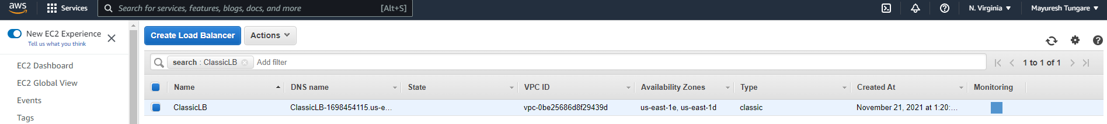

* All the EC2 instances on the Load Balancer can now been seen:

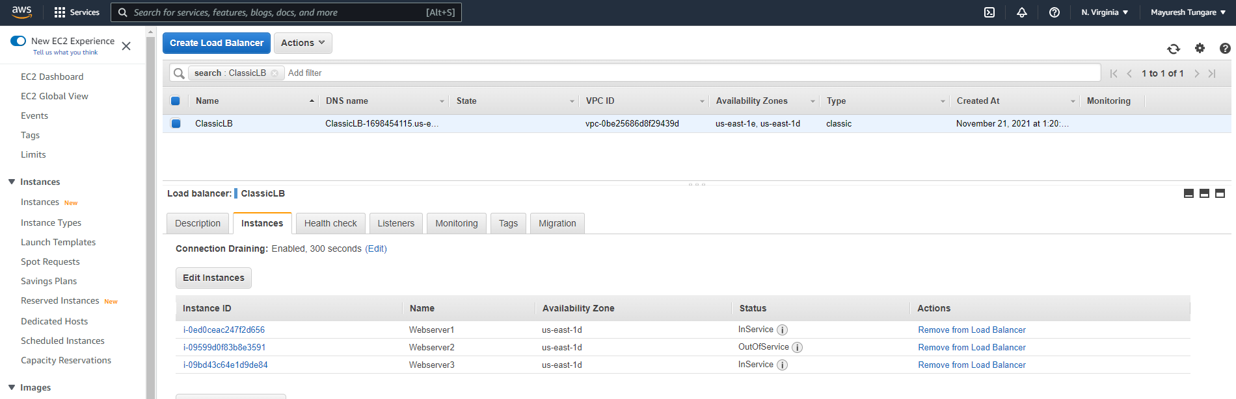

* On the Classic Load Balancer, you can now see Webserver1. On toggle, it shows messages from other webservers.

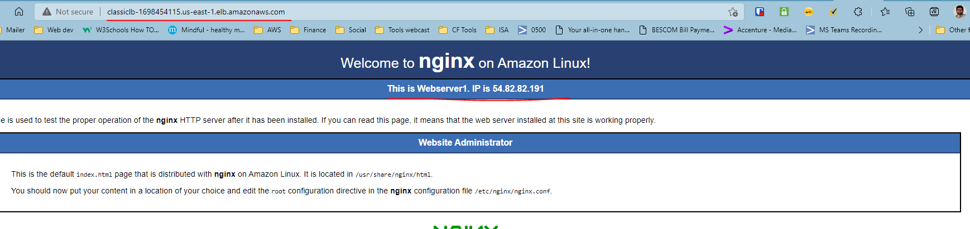

* To migrate, you can click on the ‘Migrate’ option on the Description.

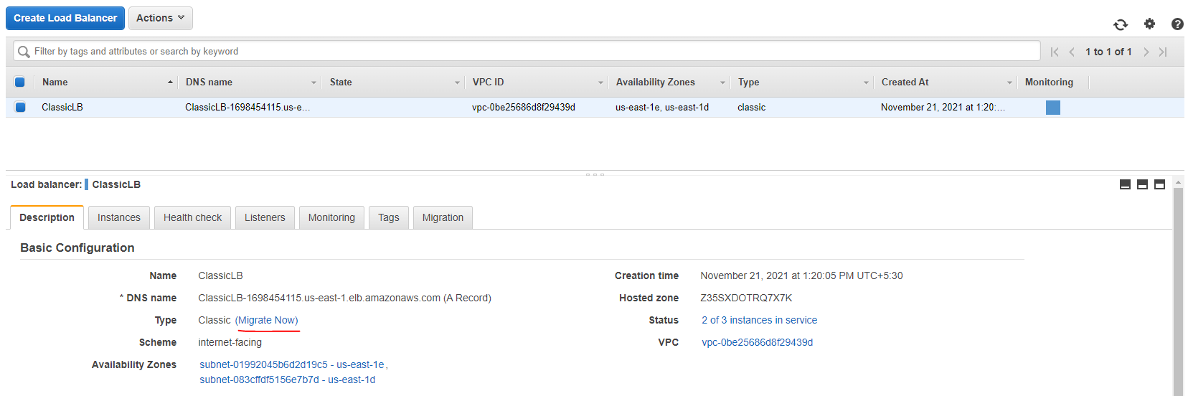

* Now Application Load Balancer will be created. Refer below to a snapshot of both the Load Balancers.

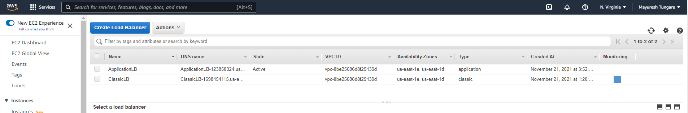

Thus, assignment is now complete.